# **Dublin Rose EPK**

## Contact

Email: [dublinrosemusic@outlook.com](mailto:dublinrosemusic@outlook.com)

Phone: 0476102011

Website: <https://dublinrose.carrd.co> (find links to all socials here)

Link Tree: <https://linktr.ee/dublinrose>

## Short Artist Bio (50 words):

Dublin Rose is a captivating singer-songwriter and guitarist from Brisbane, performing original Indie pop-rock and folk music either as a soloist or with her three piece band. Her playful and upbeat songs are a refreshing and youthful addition to the Brisbane music scene. Get ready to dance and sing along to her catchy melodies and relatable lyrics.

## 100-word bio:

Dublin Rose is a captivating singer-songwriter and guitarist from Brisbane, performing original Indie pop-rock and folk music with a three-piece band. Her playful and upbeat songs are a refreshing and youthful addition to the Brisbane music scene. Headlining numerous shows and opening for countless artists, Dublin’s music has been played on radio stations, including ABC, 4ZZZ and Bridge FM. Her latest single ‘There You Go Again’ is one of four songs on Spotify - two of which were self-produced. Drawing inspiration from artists such as Kate Miller Heidke, Stella Donnelly, Beach Bunny and Taylor Swift, Dublin’s music is guaranteed to make you dance and sing along.

**India Bio:**

Dublin Rose is a captivating singer-songwriter and guitarist from Brisbane, Australia, performing original Indie pop-rock and folk music. Her playful and upbeat songs are a refreshing and youthful addition to the Brisbane music scene. Dublin has headlined shows, opened for numerous artists, and her music has aired on ABC, 4ZZZ, and Bridge FM. She has released 4 songs on Spotify – 2 of which were self-produced. As a 2023 finalist for Brisbane City Council’s QUBE Effect, her video for her most recent single ‘There You Go Again’ won the Lord Mayor’s "People’s Choice Award." As she nears graduation with a Bachelor of Fine Arts Music from QUT, Dublin is eager to pursue her dreams in the industry and release her debut EP in early 2025.

## Press Shots:

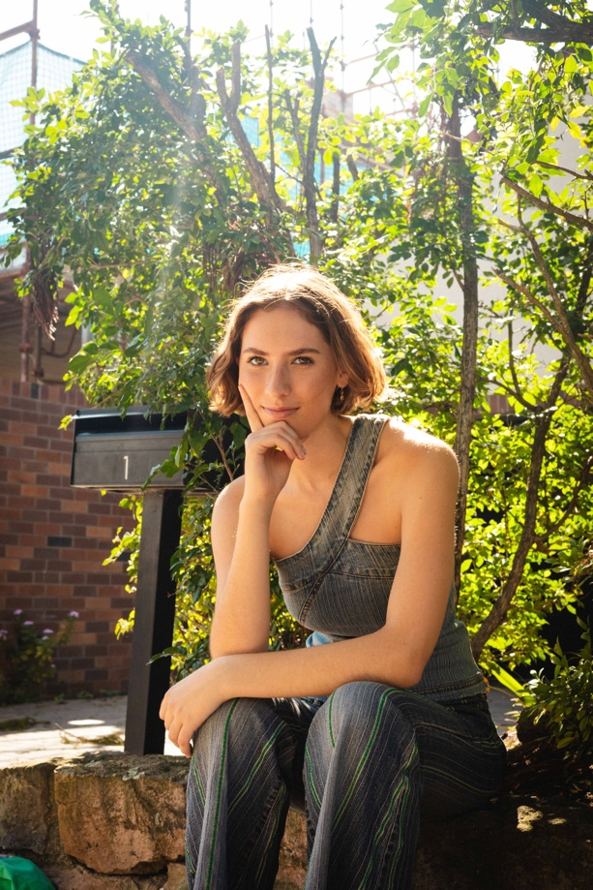

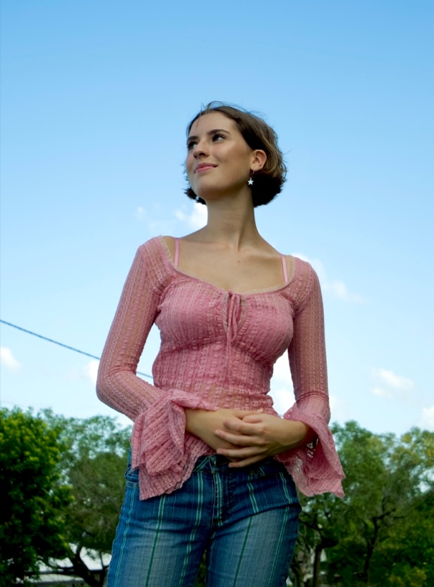

# Solo Tech Specs and Stage Plot:

1 x Vocal mics + stand

1 x PA System

1 X DI for Acoustic guitar